**CASUAL**

**Medical Receptionist**

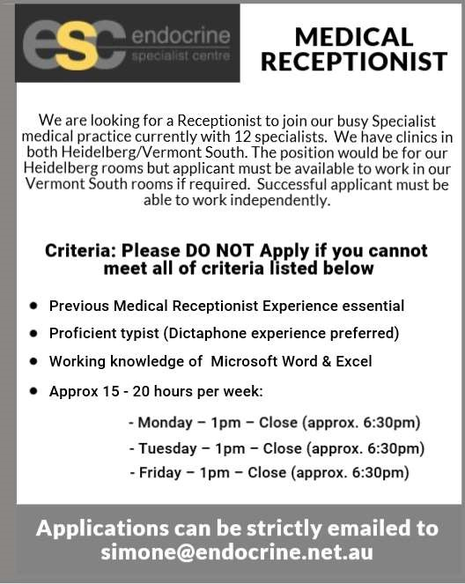

We are looking for a Receptionist to join our busy Specialist medical practice currently with 12 specialists. We have clinics in both Ivanhoe/Vermont South. The position would be for our Ivanhoe rooms but applicant must be available to work in our Vermont South rooms if required. Our clinic hours are 8.30am to 6pm. Successful applicant must be able to work independently.

**Criteria: Please DO NOT Apply if you cannot meet all of criteria listed below:**

* Previous Medical Receptionist Experience essential
* Proficient typist (Dictaphone experience preferred)
* Working knowledge of Microsoft Word & Excel
* Approx. 15 - 20 hours per week

**Applications can be confidentially emailed to** [**simone@endocrine.net.au**](mailto:simone@endocrine.net.au)